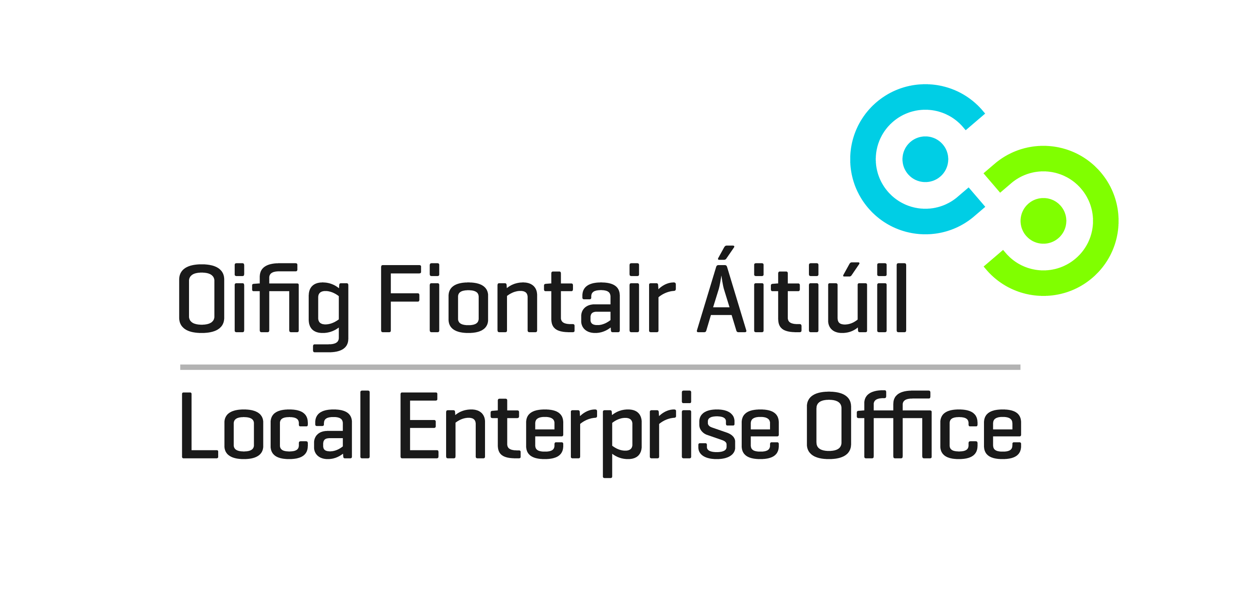****

|  |  |  |  |  |  |  |  |  |  |  |  |  |  |  |  |  |  |  |  |  |  |  |  |  |  |  |  |  |  |  |  |  |  |  |  |  |  |  |  |  |  |  |  |  |  |  |  |  |  |  |  |  |  |  |  |  |  |  |  |  |  |  |  |  |  |  |  |  |  |  |  |  |  |  |  |  |  |  |  |  |  |  |  |  |  |  |  |  |  |  |
| --- | --- | --- | --- | --- | --- | --- | --- | --- | --- | --- | --- | --- | --- | --- | --- | --- | --- | --- | --- | --- | --- | --- | --- | --- | --- | --- | --- | --- | --- | --- | --- | --- | --- | --- | --- | --- | --- | --- | --- | --- | --- | --- | --- | --- | --- | --- | --- | --- | --- | --- | --- | --- | --- | --- | --- | --- | --- | --- | --- | --- | --- | --- | --- | --- | --- | --- | --- | --- | --- | --- | --- | --- | --- | --- | --- | --- | --- | --- | --- | --- | --- | --- | --- | --- | --- | --- | --- | --- | --- | --- |
| |  |  |  | | --- | --- | --- | | **Enterprise & Innovation Workshops 2014** |  |  | |  |  |  | |  |  | **Mayo** | |  |  | Contact: Paula Prendergast | |  |  | [pprendergast@mayococo.ie](mailto:jgrehan@mayococo.ie) | |  |  | 094 904 7586 | |  |  |  | |  |  |  | | **Is my Craft Product aesthetically & financially viable?** |  | 26-May | | Facilitator Lorraine Bowen |  |  | | **Product Design & Branding Workshop** |  | 7 May /15 Sept | | Simon Dennehey & Jordan Ralph |  |  | | **Costing & Pricing accurately** |  | 25 June /22 Sept | | MarainMc Donald Lifeline Business Services or Lorraine Bowen |  |  | | **Photography to promote product to its best potential** |  | 12-May | | Pauline Rowan |  |  | | **Packaging Design Workshop** |  | 09-Jun | | Rob Reilly Scale Graphic Design |  |  | | **Branding & PR for my Craft & Design business** |  | 16 June **/29 Sept** | | Norenn D'Arcy PR & Marketiing & Jordan Ralph Designer |  |  | | **Is my product range export ready?** |  | 26 May / 6 Oct | | Lorraine Bowen Designer/ Meabh Ring |  |  | | **Merchandising my product effectively** |  | 19 May /13 Oct | | Eleanor Harpur Visual Merchandsing Expert. |  |  | | **Effective Use of Social Media in promoting my C&D product** |  |  | | Aisling Nelson | **TOTAL** | **13** | |  |  |  | |  |  |  | | FACILITATORS / TRAINERS WILL BE DRAWN FROM DCCoI Design |  |  | | Panel. |  |  |     **Enterprise & Innovation Workshops 2014** |
| **Workshop** |
| **Is my Craft Product aesthetically & financially viable?**  Facilitator: Lorraine Bowen  **WORKSHOP OVERVIEW**  This workshop is designed to allow participants to conduct a focused SWOT analysis of their current product offering. As the SWOT analysis will touch on many areas including product design, costing, packaging, production etc. this workshop, as the first in a series, will be tailored to ensure that it does not overlap with following scheduled sessions. It aims instead to highlight issues of concern that can be addressed through future sessions. In the case where CEBs have selected not to run DCCoI workshops on product design, packaging, branding, costing and pricing these areas can be covered in more detail within this workshop to ensure participants are equipped to plan for change in these key areas.  **Workshop** |
|  |
| **Product Design & Branding Workshop** |
| Facilitators: Simon Dennehy, Jordan Ralph  **WORKSHOP OVERVIEW**  A discovery of cutting edge design in consumer products, furnishing and jewellery and accessories.  **Workshop** |
| **Costing & Pricing Accurately** |
| Facilitators: Marian McDonald Lifeline Business Services, Lorraine Bowen  **WORKSHOP OVERVIEW**  This workshop is designed to help participants understand how to determine the accurate cost price and the right selling price for their products and services. It is a practical workshop designed to get existing businesses to reflect and discuss how they currently cost and price their products and services. For new creative start-ups it is an opportunity to understand the factors that affect costing and pricing and to help them decide how best to structure their business model to address those factors. We will examine the real value of what a craft maker brings to their business and ensure that this value is reflected in the price.  **Workshop** |
| **Photography to promote product to its best potential** |
| Facilitator: Pauline Rowan  **WORKSHOP OVERVIEW**  To have a fuller understanding of how photography is important for presenting your product as part of your marketing strategy. Understand the terminology of photography. Understand how to control your camera. Understand how to light in a manner that can be consistent. To be confident in knowing how to prepare images for use for Press and Social Media.  **Workshop** |
| **Packaging Design Workshop** |
| Facilitator: Rob Reilly Scale Graphic Design  **WORKSHOP OVERVIEW**  Covering case studies of unique and brilliant packaging designs and concepts. The participants will then be given a design brief before the workshop to produce product packaging and led through an accelerated design process, from concept generation and ideation, through mock-up modeling and design refinement and detailing, culminating with each person presenting a final concept and prototype of their packaging design. The objective of the workshop is to give participants an in-depth experience of the design process from beginning to end, with the added benefit of enhancing awareness of the efficacy of great packaging.  **Workshop** |
| **Branding & PR for my Craft & Design business** |
| Facilitators: Noreen D'Arcy PR & Marketing, Jordan Ralph Designer  **WORKSHOP OVERVIEW**  Noreen D’Arcy founder of award winning, bi lingual communications company D’Arcy Marketing & PR delivers highly innovative, practical and focused Public Relations Workshops. Her distinctive presentation style showcases the in-depth industry knowledge, media contacts and innovative approach to PR of her company. As a result, participants gain a valuable overview of what’s involved in developing a focused PR campaign that is results driven. Learning how to develop a dedicated media database, design, craft and write a distinctive press release and formulate ideas on how attract media attention for their brand and product while operating on a tight budget are many of the topics covered.  Participants will leave energized and ready to embrace PR having engaged in a very interactive workshop that is full of practical tips and know how.  Sample Press books and press releases are available for participants to review.  **Workshop** |
| **Is my product range export ready?** |
| Facilitator: Meabh Ring  **WORKSHOP OVERVIEW**  This workshop aims to assist participants to fully examine their readiness to begin export activity.It allows them the opportunity to assess their motivations and the reality of their current situation. They will be guided through the strategic export planning process they will need to engage in to realise their export aims.Some participants may come to the understanding that they are not ready to export or that there is perhaps enough untapped potential business in Ireland to meet the production capacity dictated by their business model.It is intended that participants will leave the training session with a clear plan of tasks that need to be completed within a set timeframe to allow them complete their decisions re engaging in export activity.  **Workshop** |
| **Merchandising my Product Effectively** |
| Facilitator: Eleanor Harpur, Visual Merchandising Expert  **WORKSHOP OVERVIEW**  Eleanor has worked as an interior stylist and retail consultant in Ireland and abroad for the past 10 years. She held an eight-year in-house position with Habitat Ireland as Creative Art Director and Retail Project Manager. Now freelance, Eleanor is the resident stylist for House & Home magazine and also works on projects ranging from catalogue photography, event styling, exhibition design, retail display, advertising and editorial styling.  Links:  <http://www.ccoienterprise.ie/ideas/article/sales-strategies>    **Workshop** |
| **Effective Use of Social Media in Promoting my Craft & Design Product**  Facilitator: Aisling Nelson  **Workshop Overview**  Aisling will demystify the jargon and explain how being social online can help your business. Attendees will come away with a greater understanding of the importance of owning your brand and how to communicate with customers and peers online. They will get an overview of the different platforms and which ones best suit their business. The insights gained, will help each business owner to start creating their online marketing plan. |
|  |